**<Project Name>: Team 17**

*Place picture of project with team members here.*

*Complete the caption, below.*

*Delete this text box before pasting in your photo!*

Team members, left to right are: <name 1>, <name 2>, <name 3>, and <name 4>.

|  |  |
| --- | --- |
| *Name* | *Class No.* |
| Daniel Li | 6014-L |
| Zihao Lu | 8445-L |
| Jinglun Huang | 0389-H |
| Jiyuan Zhao | 7815-Z |

|  |  |
| --- | --- |
| GRADING CRITERIA | MAX POINTS |
| Originality, creativity, level of project difficulty | 20 |
| Technical content, succinctness of report | 10 |
| Writing style, professionalism, references/citations | 10 |
| Demonstration of functionality | 20 |
| Overall quality/integration of finished product | 10 |
| Effective utilization of microcontroller resources | 10 |
| Significance of individual contributions* | 20 |
| Poster bonus | 10 |
| Video bonus | 10 |
| Royal Showcase participation bonus (poster and video required) | 10 |

##### \**scores assigned to individual team members may vary*

##### Scoring Multiplier:

|  |  |
| --- | --- |
| 1.0 | *Excellent – among the very best projects/reports completed this semester* |
| 0.8 - 0.9 | *Good – all requirements were amply satisfied* |
| 0.6 - 0.7 | *Average – some areas for improvement, but all basic requirements were satisfied* |
| 0.4 - 0.5 | *Below average – some basic requirements were not satisfied* |
| 0.1 - 0.3 | *Poor – very few of the project requirements were satisfied* |

**TABLE OF CONTENTS**

|  |  |
| --- | --- |
| 1.0 Introduction | 1 |
| 2.0 Interface Design | 2 |
| 3.0 Peripheral Utilization | 3 |
| 4.0 Software Narrative | 4 |
| 5.0 Packaging Design | 5 |
| 6.0 Summary and Conclusions | 6 |
| 7.0 References | 7 |
| Appendix A: Individual Contributions and Activity Logs | 8 |
| Appendix B: Interface Schematic | 17 |
| Appendix C: Software Flowcharts | 19 |
| Appendix D: Packaging Design | 21 |

1. **Introduction**

*Provide a brief functional description of your project and describe the role each team member played,*

*Length should be about one page.*

1. **Interface Design**

## *Describe any external interfaces utilized (e.g., switches, LEDs, sensors). Include your OrCAD schematic as Appendix B.*

The 9S12C microcontroller is connected to several components, including push buttons, the 74HC164 Shift Register, the HD44780U LCD, and a 273-092 8-Ohm Mini Speaker. The power for all of these devices is provided by the WDU9-300. Schematics for the entire design can be seen in Appendix B. The datasheets for the components can be seen in Section 7.0.

The HD44780U LCD is connected to the microcontroller with the 74HC164 Shift Register and Port T. The shift register is used along with SCI to quickly send 8 bits of data using only two pins. The MOSI pin of the microcontroller sends the data signal to the 74HC164, and the CLK pin sends the clocking signal. Port T pins are used as control signals to the LCD. PTT2 is connected to the RS pin, which controls whether the data is used as a character or a command. PTT3 is connected to the R/W pin, which controls if the LCD will read or write data. PTT4 is connected to the LCDCLK pin, which clocks the registers in the LCD. Each bit in the shift register is connected to the corresponding bit in the LCD data in. The datasheets for the shift register and LCD show the numbering of these pins.

Four push buttons are connected to Port AD for the user interface. They are used as active-high and connected to ground with a pull-down 10k $Ω$ resistor. Another push button is used to the reset the microcontroller. It is active-low and connected to the RES pin (Pin 30) of the microcontroller.

The red LED and the speaker are connected to Port T of the microcontroller. Both of these are directly connected between the microcontroller and ground. The LED is used as a standard output of the microcontroller, but the speaker connected to PWM Channel 0 at PTT0.

# Since the LCD needed to be on the front panel of the device, it was placed on a miniature breadboard along with the shift register. The miniature breadboard was placed on its side and taped to the back of the front panel. This design allowed us to solder a minimal amount of wires together.

# **Microcontroller Resource Utilization**

*Describe how the microcontroller’s peripherals (ATD, SCI, SPI, TIM, PWM) as well as its other on-chip resources (RTI, SRAM, flash memory, etc.) were utilized, including the mode(s) in which they were programmed to operate. Provide rationale for the choices made.*

The SPI peripheral is used by the microcontroller to interface with the 74HC164 Shift Register. Based on the shift register datasheet, the maximum frequency is always higher than 6 MHz at room temperature. Therefore, the SPI is initialized for 6 Mbps, and most significant bit first. Since the data is only being written to the shift register and not read, the SPI is initialized for master mode, single direction, and no interrupts. When data is written into the SPI data register, the SPI automatically shifts out the data to the shift register.

The timer peripheral is used for precise delays and counting how long a push button is asserted. Timer channel 7 is used for interrupts only, at a rate of 1 ms. First, channel 7 is enabled and set to output compare mode with interrupts enabled. The timer is initialized for a prescale of 16, and TC7 = 1500, with reset when output compare channel 7 is asserted. Morse code is heavily dependent on the timing of signals, so the timer is necessary to ensure that time periods are accurate. With an interrupt rate of 1 ms, the program can easily and accurately wait certain amounts of time.

The PWM peripheral is used to create a waveform for the speaker. The PWM will output on Channel 0, so PWM Channel 0 is enabled, using Clock A and MODRR is used to route it to PTT0. The frequency of the input square wave should be between 1 kHz and 2 kHz to be an audible sound. Therefore the PWM is initialized for active-high, no concatenate, left-aligned, with a prescale of 64 and a period of 255. This results in a frequency of about 24000000/255/64 = 1470 Hz. The PWM and speaker can be easily turned off by setting the duty cycle to 0 and turned on by setting it to a nonzero value such as 0x7F.

The RTI system is used to sample push buttons. The interrupt rate is set to 2.048 ms to be fast as well as accurate. The previous state of the push buttons is stored in a variable and compared to the current state. If the buttons changed from inactive to active, then that button’s flag is set.*.*

1. **Software Narrative**

*Describe what the software does and how it is organized/structured (i.e., event-driven, state machine, etc.). Submit your complete software listing on-line separately. Include a flowchart to document program structure in Appendix C.*

The software in the Morse Code Converter is best described as a state machine (flag-driven) approach. The program initializes all flags, tables, and peripherals before entering the main loop. The main loop of the program checks for push button flags set by the RTI and performs the appropriate action. A more detailed flowchart can be found in Appendix C.

If the mode1 flag is set and the program is currently in mode 2, the input string is reset and mode 1 is entered. If the flag is set while it is in mode 1, the currently selected character is entered into the input string. If the leftpb flag is set, the cursor for the currently selected character moves left. Similarly, the rghtpb flag causes the cursor to move right. After each cursor move, if the cursor is outside the bounds of the screen, the page is changed. If BS (backspace) is selected, then the last entered character is deleted. If EN (enter) is selected, then the program begins conversion from the input string to morse code. During the conversion, the LED on the front panel will light up for 0.25 seconds for a dot and 0.75 seconds for a dash. While the LED is lit, a speaker connected to the PWM is activated. The amount of time in between actions is controlled by timer interrupts. The program waits for 250 interrupts for 0.25 seconds, and 750 interrupts for 0.75 seconds. In mode 1, the LCD displays a character menu on the top row and the input string on the bottom row.

If the mode2 flag is set, the program enters mode 2 and clears the input string. The program takes in morse input from the mode2 button until either 16 characters have been entered or user breaks the loop by changing to mode1. Timer interrupts constantly sample the mode2 push button, which allows the program to detect how long the button has been asserted or deasserted. These values are converted into a Morse sequence of dots and dashes. Also, the timer interrupts light the LED and activate the speaker when the mode2 button is asserted. After a Morse sequence is entered, it will be converted into a letter and entered into the input string. If an unrecognized sequence of Morse code is entered, such as ‘-...’, then the LCD displays an error and discards that sequence. While in mode 2, if the leftpb flag is set, the last entered character will be deleted. In mode 2, the LCD displays the current Morse sequence on the top row and the input string on the bottom row.

Lookup tables are used to convert from morse code to characters and from characters to morse code. Morse code is converted into a base 4 number with the most significant digit being the first input. A dot in Morse code is converted to a 1, a dash is converted to a 2. If the entry does not contain a total of four dots and dashes, the rest of the values are filled with 0s. For example, ‘--..’ would convert to 2211 (165 in decimal) and ‘-.-’ would convert to 2120 (152 in decimal). For the table that converts characters into morse code, morsetable[0] corresponds to A, morsetable[1] corresponds to B, etc. Since A is ‘.-’ in Morse code, morsetable[0] is 1200 base 4 (94 in decimal). B is ‘-...’, so morsetable[1] is 2111 base 4 (149 in decimal). The inverse table is morsetable2, which converts morse code into characters. morsetable2[94] is equal to ‘A’ and morsetable2[149] is equal to ‘B’.

1. **Packaging Design**

*Describe the packaging design for your project; include drawings/photos in Appendix D.*

*Length should be about one page.*

1. **Summary and Conclusions**

*Describe what you learned from completing the project and what you might do to improve your design if you had more time.*

*Length should be about one page.*

1. **References**

*List any references (e.g., data sheets, application notes, web sites) used in formulating your solutions.* ***Be sure to cite these references in your report.***

*NOTE: Use APA or IEEE format.*

74HC164. Retrieved from <http://www.nxp.com/documents/data_sheet/74HC_HCT164.pdf>

HD44780U (LCD-II). Retrieved from <http://www.serialwombat.com/parts/hd44780.pdf>

WDU9-300. Retrieved from <http://www.mouser.com/ds/2/410/WDU9-300-224465.pdf>

**Appendix A:**

**Individual Contributions**

**and**

**Activity Logs**

**Activity Log for:** <name-1> **Role:** <role on team>

|  |  |  |  |  |
| --- | --- | --- | --- | --- |
| ***Activity*** | ***Date*** | ***Start Time*** | ***End Time*** | ***Time Spent*** |
| **Team meeting to plan project** | 4/5/2013 | 8:00 | 9:00 | 1h |
| Wrote the main program | 4/6/2013 | 7:00 | 9:00 | 2h |
| Went to Radio shack |  |  |  |  |
| In lab discussion for particular parts needed | 4/9 | 7:00 | 9:00 | 2h |
| Team meeting to discuss the final version of project | 4/14 | 7:00 | 8:00 | 1h |
| Started wiring | 4/15 | 7:00 | 12:00 | 5h |
| Finish wiring | 4/16 | 12:00 | 5:00 | 5h |
| Start packaging | 4/17 | 4:00 | 7:00 | 3h |
| Finish packaging | 4/18 | 1:00 | 4:00 | 3h |
| Demon | 4/19 | 10:30 | 10:45 | 15min |
|  |  |  |  |  |
|  |  |  |  |  |
|  |  |  |  |  |
|  |  |  |  |  |
|  |  |  |  |  |
|  |  |  |  |  |
|  |  |  |  |  |
|  |  |  |  |  |
|  |  |  |  |  |
|  |  |  |  |  |

**Written Summary of Technical Contributions:** <name-1>

*Provide a concise but sufficiently detailed description of your technical contributions to the project.*

*Length should be about one page.***Activity Log for:** <name-2> **Role:** <role on team>

|  |  |  |  |  |
| --- | --- | --- | --- | --- |
| ***Activity*** | ***Date*** | ***Start Time*** | ***End Time*** | ***Time Spent*** |
|  |  |  |  |  |
|  |  |  |  |  |
|  |  |  |  |  |
|  |  |  |  |  |
|  |  |  |  |  |
|  |  |  |  |  |
|  |  |  |  |  |
|  |  |  |  |  |
|  |  |  |  |  |
|  |  |  |  |  |
|  |  |  |  |  |
|  |  |  |  |  |
|  |  |  |  |  |
|  |  |  |  |  |
|  |  |  |  |  |
|  |  |  |  |  |
|  |  |  |  |  |
|  |  |  |  |  |
|  |  |  |  |  |
|  |  |  |  |  |
|  |  |  |  |  |

**Written Summary of Technical Contributions:** <name-2>

*Provide a concise but sufficiently detailed description of your technical contributions to the project.*

*Length should be about one page.***Activity Log for:** <name-3> **Role:** <role on team>

|  |  |  |  |  |
| --- | --- | --- | --- | --- |
| ***Activity*** | ***Date*** | ***Start Time*** | ***End Time*** | ***Time Spent*** |
|  |  |  |  |  |
|  |  |  |  |  |
|  |  |  |  |  |
|  |  |  |  |  |
|  |  |  |  |  |
|  |  |  |  |  |
|  |  |  |  |  |
|  |  |  |  |  |
|  |  |  |  |  |
|  |  |  |  |  |
|  |  |  |  |  |
|  |  |  |  |  |
|  |  |  |  |  |
|  |  |  |  |  |
|  |  |  |  |  |
|  |  |  |  |  |
|  |  |  |  |  |
|  |  |  |  |  |
|  |  |  |  |  |
|  |  |  |  |  |
|  |  |  |  |  |

**Written Summary of Technical Contributions:** <name-3>

*Provide a concise but sufficiently detailed description of your technical contributions to the project.*

*Length should be about one page.***Activity Log for:** <name-4> **Role:** <role on team>

|  |  |  |  |  |
| --- | --- | --- | --- | --- |
| ***Activity*** | ***Date*** | ***Start Time*** | ***End Time*** | ***Time Spent*** |
|  |  |  |  |  |
|  |  |  |  |  |
|  |  |  |  |  |
|  |  |  |  |  |
|  |  |  |  |  |
|  |  |  |  |  |
|  |  |  |  |  |
|  |  |  |  |  |
|  |  |  |  |  |
|  |  |  |  |  |
|  |  |  |  |  |
|  |  |  |  |  |
|  |  |  |  |  |
|  |  |  |  |  |
|  |  |  |  |  |
|  |  |  |  |  |
|  |  |  |  |  |
|  |  |  |  |  |
|  |  |  |  |  |
|  |  |  |  |  |
|  |  |  |  |  |

**Written Summary of Technical Contributions:** <name-4>

*Provide a concise but sufficiently detailed description of your technical contributions to the project.*

*Length should be about one page.*

**Appendix B:**

**Interface Schematic**

*Paste a copy of your OrCAD interface schematic here.*

*Be sure to clearly identify the team member(s) responsible for producing this documentation.*

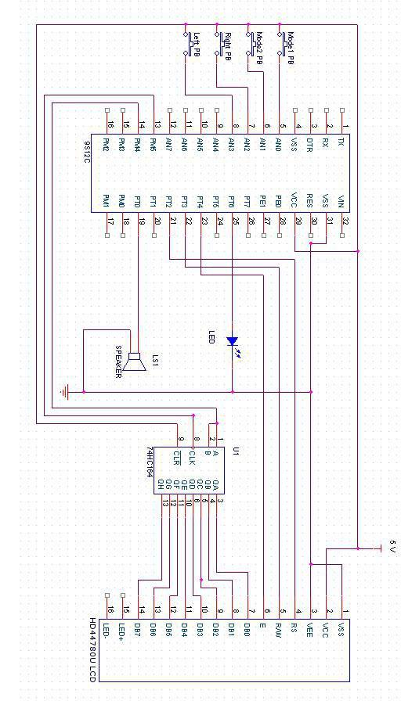

**Appendix C:**

**Software Flowcharts**

*Include software flow diagrams and/or pseudo code here.*

*Be sure to clearly identify the team member(s) responsible for producing this documentation.*

*NOTE: Software source listing file must be submitted on-line and should NOT be included here.*

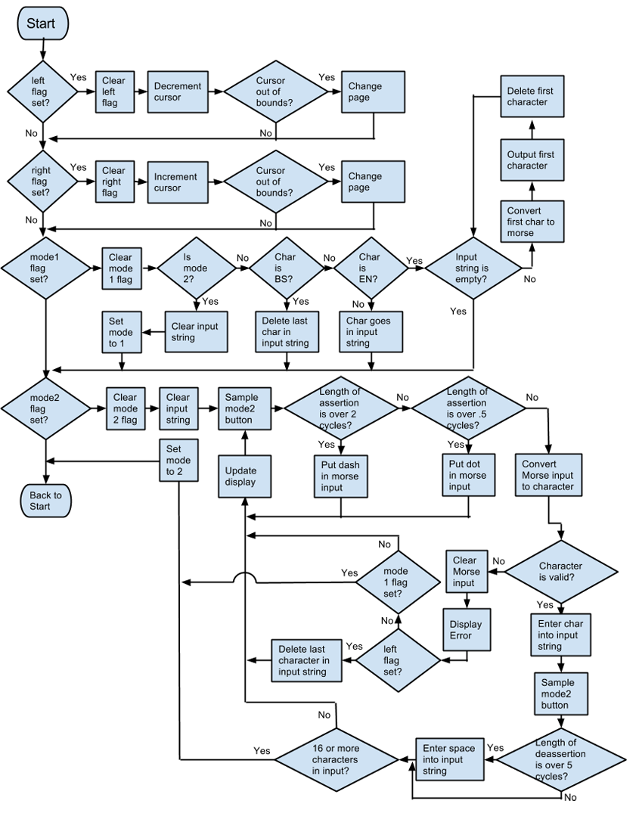

**Appendix D:**

**Packaging Design**

*Paste illustrations/pictures of your project packaging here.*

*Be sure to clearly identify the team member(s) responsible for producing this documentation.*

**NOTE: Use the on-line form on the Mini-Project website page to submit this report (.doc file) along with your source code file (.c or .zip)**

Delete this text box before submitting your report! Also, delete all *highlighted instructions* provided in this skeleton file as you edit each section of your report.